Name: ________________
7 Writing- Persuasive Essay
Step 1: Choose the topic or issue that you will be creating a thesis statement about.
- Should children be required to read more?

- Are there more effective punishments than grounding? *

- Are schools punishments for bullying effective?

- Should all students should wear school uniforms?

- Should video games be used in the classroom?

- Are beauty contests (pageants) bad for body image and self-confidence?

- Is medical testing on animals necessary?

- Should homework be banned?*

- Does social media have a negative impact on today’s youth?*

- Should sports be coed?*

Step two: Research your topic and create an informed opinion. To complete your research you must complete the following tasks:
- Find 3 sources that advocate for (support) the topic
- Find 3 sources that are against the topic
- Skim and scan the articles finding and highlighting supporting details
- Complete a source page (see template below) for each article and create a works cited.
- Everything must be in MLA format! This includes the headings on ALL of your papers that will be handed in.

Step three: Develop a thesis statement

Step Four: Writing body paragraphs based on our research
- Topic Sentence (tells what the paragraph is going to be about)
- Include Evidence to support the topic sentence and your overall claim/thesis
- Cite and Explain the evidence properly (what it means and why it's important to
your claim)
- Concluding Sentence that wraps up the paragraph and restates the main point.

Step Five: Writing an introduction
-Create an effective hook that will draw the reader in
- Transition into the thesis statement by outlining your argument
- State your thesis.

Step Six: Writing a Conclusion
- Restate your thesis statement
- Summarize your most important points
- Leave the reader with some food for thought- a “call to action”

Name
Teacher’s Name
Subject
Date
Example Source Page
Source 1 in MLA format:

Conley, Miaela. “More TV, Less Self-Esteem, Except for White Boys”. ABC News. ABC
News Network. 30 May 2012. Web. 28 October 2014.

What is the stance (opinion/position) of this text?

Television has a negative impact on the majority of youth with the exception of white males.

Choose 3-5 pieces evidence that supports the position- write the quotes below and cite them properly.
- The study authors said that while white male TV characters tend to hold positions of power in prestigious occupations, have a lot of education and beautiful wives, the TV roles of girls and women tend to be less positive and more one-dimensional.
- Black men and boys are often criminalized on TV, the researchers said, which can affect their feelings of self-worth.
- Children’s self-esteem generally goes down as TV watching goes up. But white boys are the exception, according to a new study published in the journal Communications Research.
- Female characters are often sexualized, and success is often measured according to how they look.
Do you agree or disagree with this article and WHY?
I agree with this article because a lot of the television programs I can think of promote these stereotypes. For example, in the show Pretty Little Liars the leading female figures have a large emphasis on outer appearance.

Name
Teacher’s Name
Subject
Date
Source Page Template

Source 1 in MLA format:

What is the stance (opinion/position) of this text?

Choose 3-5 pieces evidence that supports the position- write the quotes below and cite them properly.

Do you agree or disagree with this article and WHY?

WARNING!
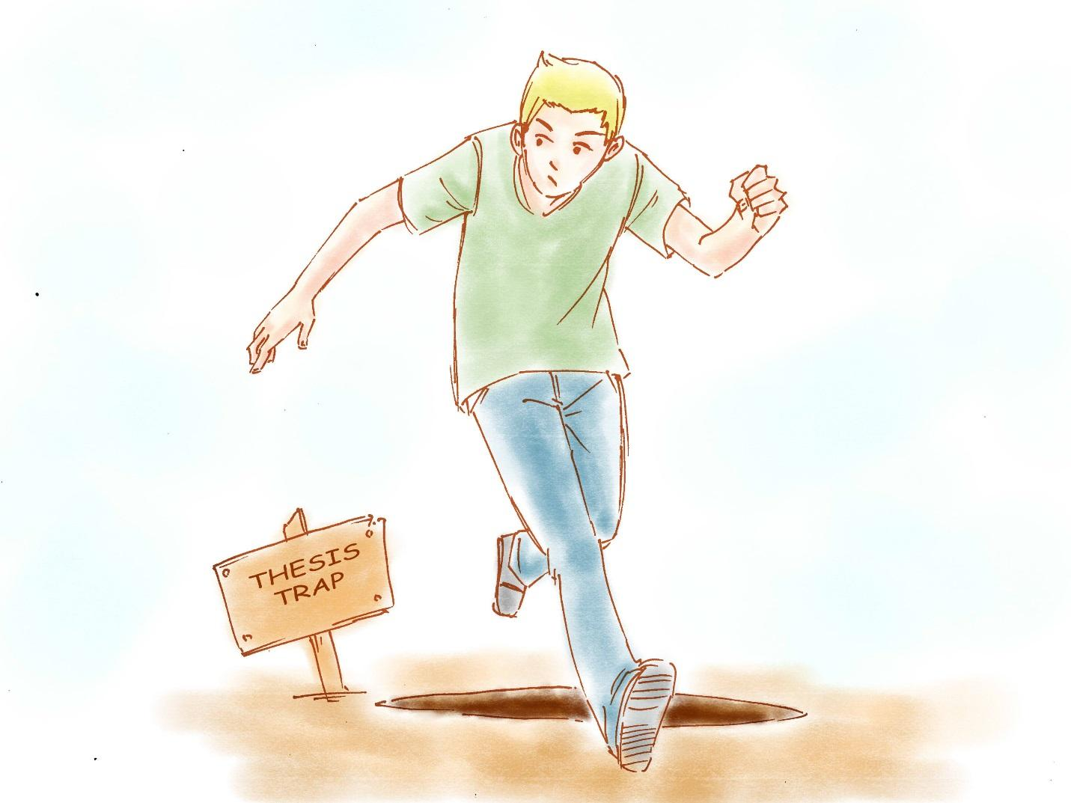
Don't fall into these thesis traps. The following pieces of advice can help you make your thesis even better and avoid some common problems people have with theses:
- Do not form your thesis as a question. Your thesis should be a statement, an argument about how you view a situation. Posing the thesis as a question doesn't give someone reading the introduction a clear idea about where you stand.
- Do not make your thesis into a list. You can always make your thesis bigger, but that's not the point of an essay. The point of an essay is to pick a few examples, shape them into an argument, and boil that argument down into a thesis.
- Do not use your thesis as a springboard to talk about new issues. You should be able to trace a clear line from the hook of the intro to the argument in your thesis. Having your thesis veer off into a different direction is confusing.
- Unless you're writing a personal essay, do not write the thesis in the first person. To make the thesis sound more authoritative, avoid this personal pronoun

