Trait | Direct Quote (be sure to copy down the page number)
 | (____________).
Explain how trait and quote prove this person is heroic:

 | (____________).
Explain how trait and quote prove this person is heroic:
 | (____________).
Explain how trait and quote prove this person is heroic:

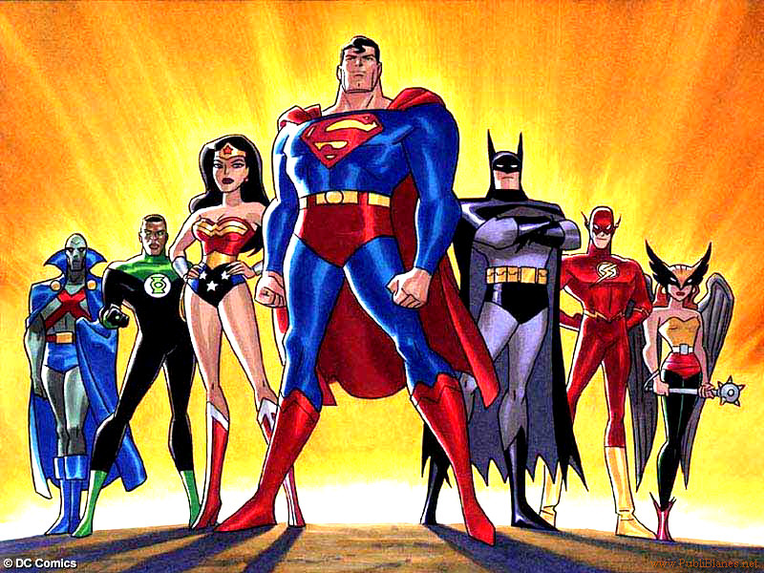
Directions continued…
- Explain how the quote proves that the character embodies the chosen trait and make him/her a hero.
Directions: Pick a character from our reading that you deem heroic and do the following:
- Choose a heroic trait that this character embodies.
- Find a direct quote that proves the character has this trait

